**Lab - How to run an eDiscovery search in a Core eDiscovery case?**

The eDiscovery Search tool can be used to search for content across Microsoft 365 data sources using keywords and conditions. The results of the search can then be exported to a local computer.

* **Step 1:**Navigate to the Security and Compliance center. Click “Core eDiscovery” under the eDiscovery drop-down on the navigation menu bar on the left-hand side of the screen.
* **Step 2:** Click “Searches'' from the top menu bar. Click “+New Search”.

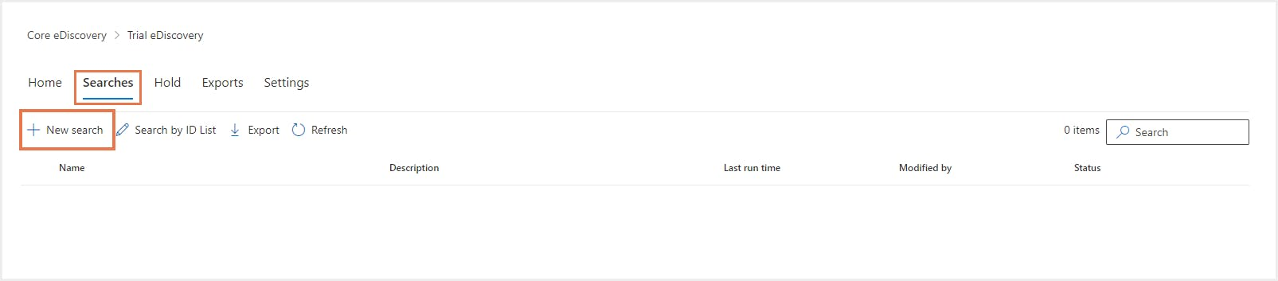

* **Step 3:**Type a name and description (optional) for the new search. Click “Next”.
* **Step 4:**Choose the location to search for content. Example: - Specific users, groups, or teams under Exchange mailboxes - Specific sites and OneDrive accounts or add the URL for a Microsoft Team, Office 365 Groups, or Yammer Groups SharePoint site. Click “Next”.

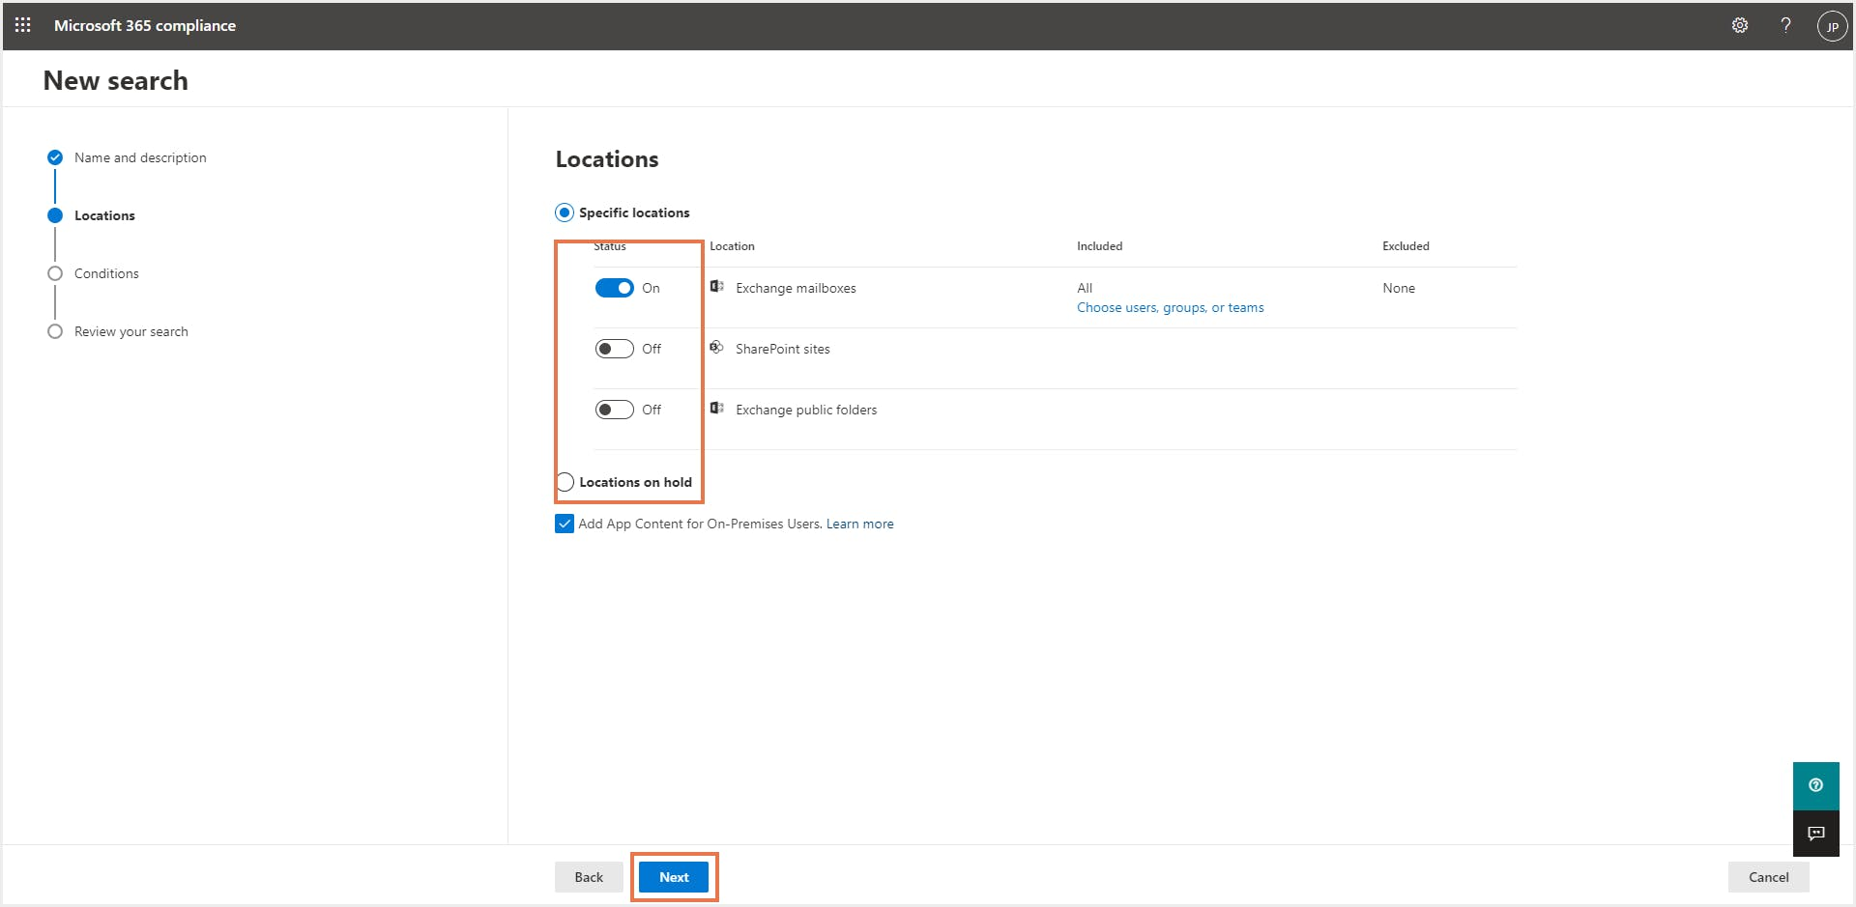

* **Step 5:**Add conditions for the search if needed. This could include specific keyword(s) and add conditions to search for the keyword. Click “Next”.

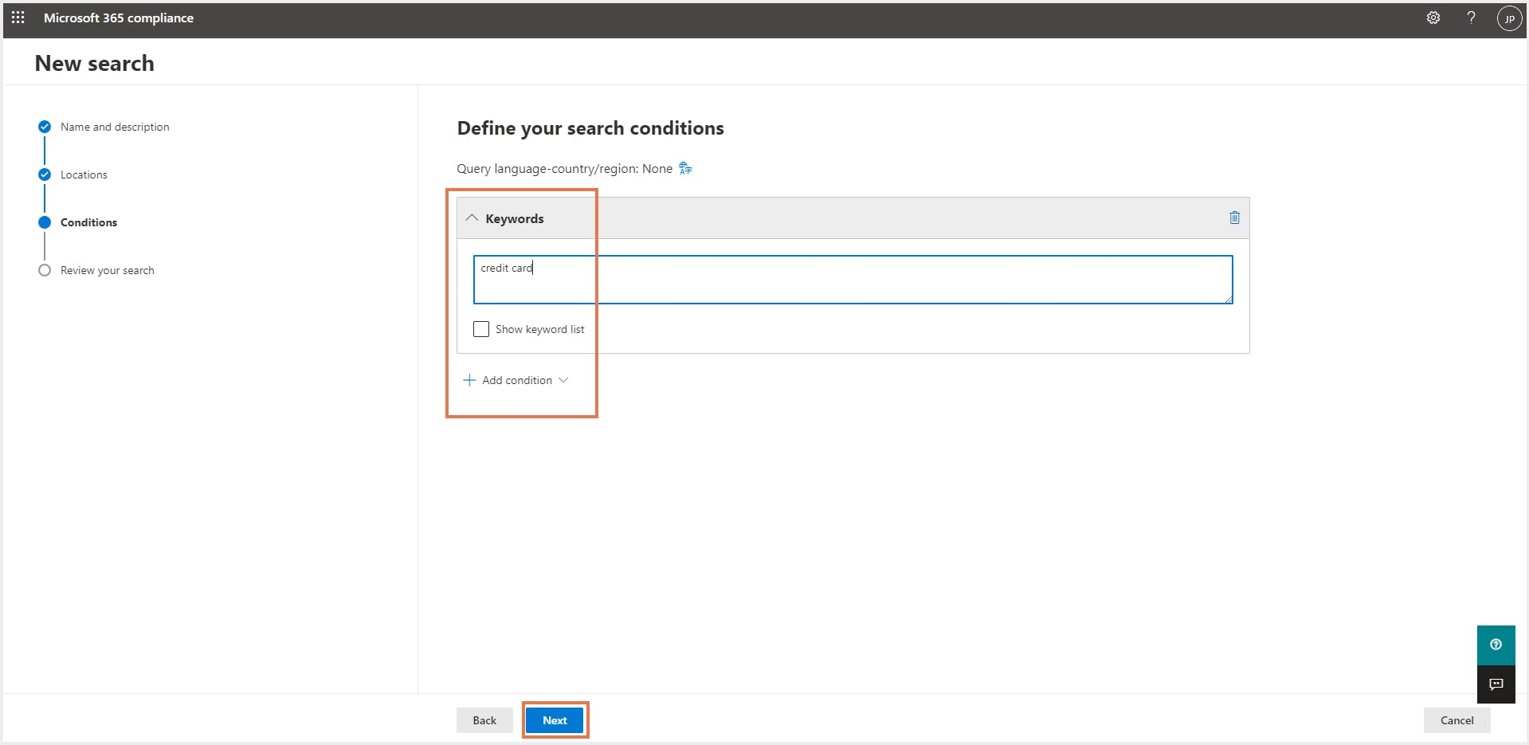

* **Step 6:**Review the search and click “Submit”. Once the content search run is complete, administrators can take further action like “Edit search,” “Rerun search,” etc. They can also export the search results as a .csv or a compressed .zip file by clicking “Export results”.

